Countries which speak Portuguese

Around 250 million people around the world speak Portuguese. It is either an official language, or is spoken by a significant portion of the population, in the following 11 countries/provinces:

1. Brazil (S. America) 10. The Azores (west of Portugal)
2. Portugal (Europe) 11. Madeira (southwest of Portugal)
3. Macau (China)
4. Timor-Leste (Australasia) It is also spoken in:
5. Angola (Africa) 12. Luxembourg (Europe)
6. Mozambique (Africa) 13. Goa (India)
7. Guinea-Bissau (Africa) 14. Galicia (Spain)
8. Sao Tome and Principe (Africa)
9. Cape Verde (Africa)

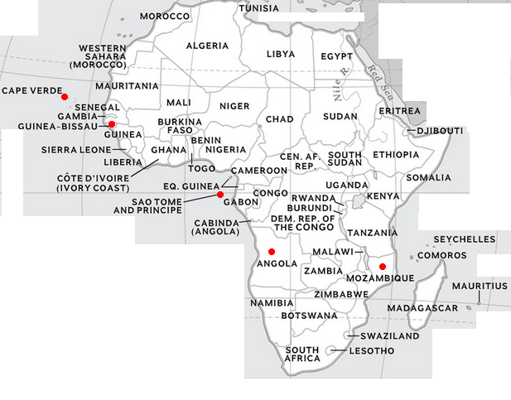

Examples of Portuguese: https://www.youtube.com/watch?v=8uFkciZLnNU (7 mins)

Portuguese is one of the top 10 most spoken languages in the world (in terms of population):
1. English 6. French
2. Mandarin 7. Malay
3. Hindi / Urdu 8. Russian
4. Spanish 9. Bengali
5. Arabic 10. Portuguese

Countries which speak English

English is either an official language, or is predominantly spoken, in the following 49 countries:

Antigua and Barbuda  Australia  Bahamas  Barbados  Belize  Botswana  Canada  Dominica  Fiji  Gambia  Ghana  Grenada  Guyana  India  Ireland  Jamaica  Kenya | Kiribati  Liberia  Malawi  Malta  Marshall Islands  Mauritius  Micronesia  Namibia  New Zealand  Nigeria  Pakistan  Palau  Panama  Papua New Guinea  Philippines  Rwanda  Saint Kitts and Nevis | Saint Lucia  Saint Vincent and the Grenadines  Seychelles  Sierra Leone  Singapore  South Africa  Sri Lanka  Swaziland  Tanzania  The United Kingdom  The United States of America  Trinidad and Tobago  Vanuatu  Zambia  Zimbabwe

- English has official status in at least 75 countries with a total population of over two billion.
- There are more people who speak English as a second language than as a first.
- About 750 million people speak English as a foreign language.
- 25% of the world's population speak English, at least a little. Many more are learning!

The difference between a “second language” and a “foreign language”:
- English as a Second Language (ESL) – This refers to learning English in a country where English is widely spoken and used in daily life. For example, a Spanish speaker who moves to the U.S.A. and learns English would be learning it as a “second language”.
- English as a Foreign Language (EFL) – This refers to learning English in a country where English is not commonly spoken or used in daily life. For example, a Japanese student studying English in Japan is learning it as a “foreign language”.
In other words, ESL learners are surrounded by English, while EFL learners are not.

Second Languages. The most spoken second languages in the world are:
1. English 2. Hindi 3. French 4. Mandarin 5. Indonesian
6. Russian 7. Urdu 8. Swahili 9. Spanish 10. German

There are significantly more Spanish speakers than Portuguese speakers worldwide. Around 500–560 million people speak Spanish as a first language, with over 600 million total speakers. It is the fourth most spoken language in the world by total speakers. Whereas, around 230–260 million people speak Portuguese as a first language, with about 270 million total speakers worldwide.

Some differences in English versions: https://www.youtube.com/watch?v=fy-bd5AC-Ms (3 mins)

